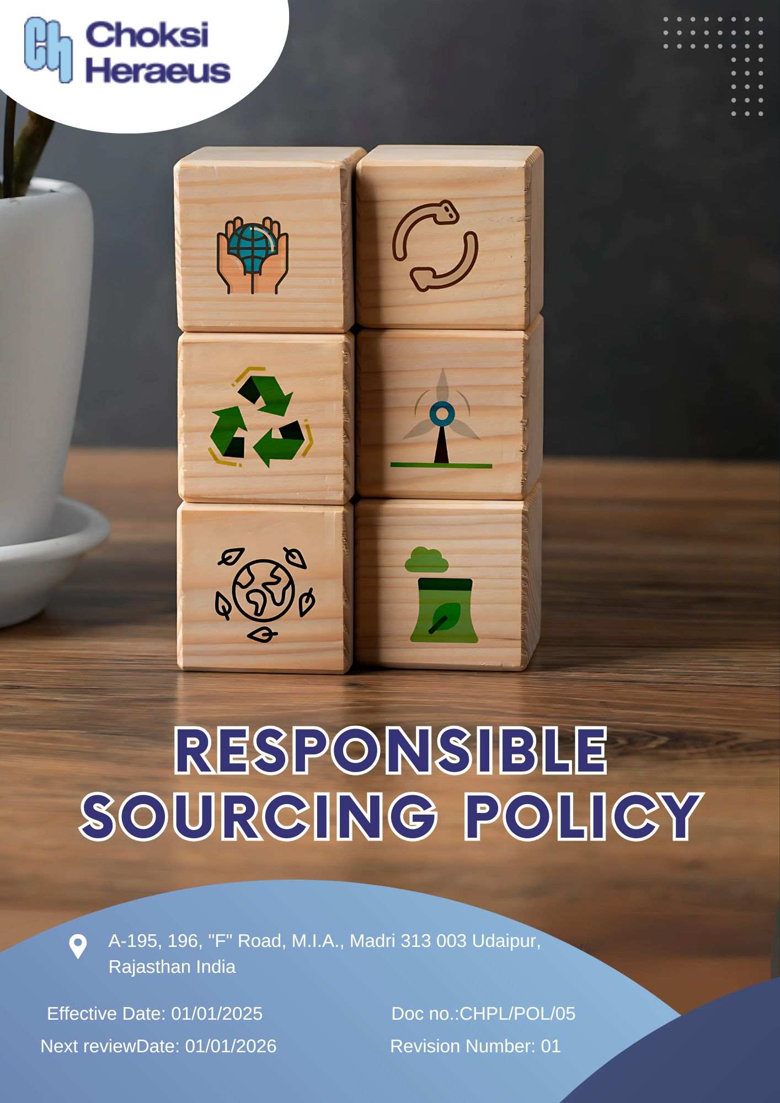

.

Table of Contents
INTRODUCTION 3
SCOPE 3
POLICY DECLARATION 3
KEY FOCUS AREAS 4
OBJECTIVES AND TARGETS 4
SDG ALIGN 5
RESPONSIBILITIES 6
REVIEW MECHANISM 6
EMPLOYEE ACKNOWLEDGEMENT FORM 7

INTRODUCTION
Choksi Heraeus Pvt. Ltd., a leading provider of precious metal-based products and solutions, is committed to building a responsible and sustainable supply chain that reflects the highest standards of ethics, integrity, and accountability. We recognize that our sourcing decisions can have far-reaching impacts on human rights, the environment, and broader society. Therefore, we prioritize working with suppliers and partners who share our values and are committed to operating transparently and responsibly.
This Responsible Sourcing Policy outlines our expectations for ethical business conduct, legal compliance, environmental stewardship, and social responsibility throughout our supply network. It serves as a foundation for our due diligence processes, supplier assessments, and engagement with stakeholders to ensure that our sourcing activities contribute positively to the global community.
We align our approach with internationally recognized frameworks such as the OECD Due Diligence Guidance for Responsible Supply Chains, and promote traceability, fair labor practices, and conflict-free material sourcing. Through this policy, Choksi Heraeus aims to foster long-term relationships with suppliers who demonstrate a shared commitment to sustainable development, continuous improvement, and responsible business practices.

SCOPE
This policy applies to all sourcing and procurement activities at Choksi Heraeus Pvt. Ltd., including raw materials, components, and services. It extends to the entire supply chain, covering suppliers, contractors, and business partners and ensures responsible practices related to labor, environment, compliance, and human rights across all regions of operation.
Sr. No. | Site | Address
1 | CHOKSI HERAEUS PVT. LTD | A-195, 196, "F" Road, M.I.A., Madri 313 003 Udaipur, Rajasthan India

POLICY DECLARATION
Choksi Heraeus Pvt. Ltd. is committed to sourcing materials and services in a responsible, ethical, and sustainable manner. We require all suppliers and business partners to adhere to our standards on environmental protection, human rights, fair labor, and anti-corruption. This policy reflects our dedication to building transparent, resilient, and socially responsible supply chains that contribute to long-term value creation and stakeholder trust.

KEY FOCUS AREAS
- Eco-Conscious Procurement: Preference for suppliers who actively minimize environmental impacts through resource efficiency, emission control, and responsible waste management.
- Fair Labor & Working Conditions: Commitment to safe workplaces, fair wages, and the elimination of child, forced, or exploitative labor across all tiers of the supply chain.
- Conflict-Free & Traceable Materials: Alignment with global frameworks like the OECD Guidance to ensure responsible sourcing and full traceability of key raw materials.
- Ethical Supplier Conduct: Expectation of legal compliance, anti-corruption, and full transparency in business practices from all partners.
- Collaborative Sustainability: Engagement with suppliers to drive innovation, reduce environmental impact, and enhance long-term social value.
- Local & Inclusive Sourcing: Support for community-based suppliers and inclusion of diverse, small, and responsible enterprises in the supply base.

OBJECTIVES AND TARGETS
The following targets are set with FY 2022-23 as the baseline year, that reflects our commitment to advancing responsible sourcing practices across environmental, social, and ethical dimensions of our supply chain with targets set to be achieved by FY 2028-29.
- Eco-Conscious Procurement
- Promote environmentally sustainable procurement by partnering with suppliers who demonstrate measurable environmental responsibility.
- Ensure 100% of suppliers comply with Choksi Heraeus’ environmental standards by FY 2028-29.
- Increase procurement from ISO 14001 certified suppliers by 50% by FY 2028-29.
- Achieve a 10% reduction in supplier-related carbon emissions per unit of product procured by FY 2028-29.

- Fair Labor & Working Conditions
- Guarantee that all suppliers adhere to fair labor practices, including the prohibition of child and forced labor, provision of fair wages, and assurance of safe working environments.
- Conduct annual audits covering labor standards across 100% of Tier 1 suppliers.
- Maintain 100% supplier compliance with the company’s child and forced labor policies.
- Reach 50% verified compliance with labor and human rights benchmarks among suppliers by FY 2028-29, with ongoing monitoring and engagement.

- Conflict-Free & Traceable Materials
- Source raw materials responsibly by ensuring traceability and avoiding conflict affected or high-risk areas.
- Maintain 100% traceability for all raw materials by FY 2028-29
- Ensure 100% compliance with OECD Due Diligence Guidance among mineral suppliers by FY 2028-29.

- Ethical Supplier Conduct
- Promote integrity and accountability by engaging suppliers who follow ethical business practices and legal compliance.
- Integrate anti-corruption clauses in 100% of supplier contracts by FY 2028-29.
- Deliver ethics and compliance training to 90% of key suppliers by FY 2028-29.

- Collaborative Sustainability
- Partner with suppliers to co-create sustainable innovations and improve the collective environmental and social impact of the supply chain.
- Launch a joint supplier sustainability initiative by FY 2028-29.
- Increase supplier participation in sustainability reporting by 40% by FY 2028-29.

- Local & Inclusive Sourcing
- Strengthen the local economy and foster diversity by sourcing from community-based and underrepresented suppliers.
- Increase national sourcing by 50% by FY 2028-29.
- Ensure 15% of supplier base includes small or diverse businesses by FY 2028-29.

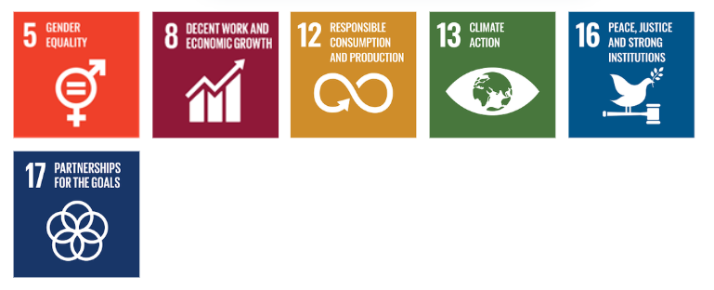
TARGETS IN ALIGNMENT WITH SDGS

RESPONSIBILITIES
- Procurement Team is responsible for integrating responsible sourcing principles into supplier selection, contract terms, and ongoing evaluations.
- Sustainability Team monitors supplier performance on environmental, social, and ethical parameters and supports improvement initiatives.
- Suppliers are expected to comply with Choksi Heraeus’ sourcing standards, provide required disclosures, and cooperate during audits and assessments.
- Senior Management ensures oversight, resource allocation, and enforcement of the policy through regular reviews and strategic direction.
- All Employees involved in sourcing or supplier engagement are expected to uphold this policy and report any violations or concerns through established channels.

REVIEW MECHANISM
The Responsible Sourcing Policy will be reviewed annually Procurement officer to ensure its continued relevance, effectiveness, and alignment with evolving regulatory requirements, international best practices, and business priorities. The review process will be overseen by the Procurement and Sustainability Teams, in coordination with relevant department heads.
Supplier compliance will be assessed through regular audits, sustainability scorecards, and feedback mechanisms. Findings from these reviews will inform corrective actions, supplier engagement plans, and policy updates. Any significant updates or improvements to the policy will be approved by senior management and communicated across the supply chain.

Effective Date: 01.01.2025
Next Review Date: 01.01.2026
Approved By:

EMPLOYEE ACKNOWLEDGEMENT FORM
I hereby acknowledge that I have read and understood the Responsible Sourcing Policy of Choksi Heraeus Pvt. Ltd. I am aware of the company’s commitment to ethical, transparent, and sustainable sourcing practices, particularly in the procurement and handling of precious metals and related materials.
I understand that responsible sourcing includes respecting human rights, avoiding materials linked to conflict or illegal practices, ensuring fair labor conditions throughout the supply chain, and complying with all applicable environmental and social regulations. I recognize that upholding these standards is a shared responsibility that contributes to the integrity and sustainability of our operations.
By signing this document, I confirm my commitment to supporting responsible sourcing practices, reporting any sourcing-related concerns through appropriate channels, and participating in required training and awareness initiatives. I affirm my role in helping Choksi Heraeus build a supply chain that reflects our values of ethics, accountability, and social and environmental responsibility.

Employee Name  Employee ID  Date  Signature | :_______________________________  :_______________________________ :________________________________  : _______________________________

